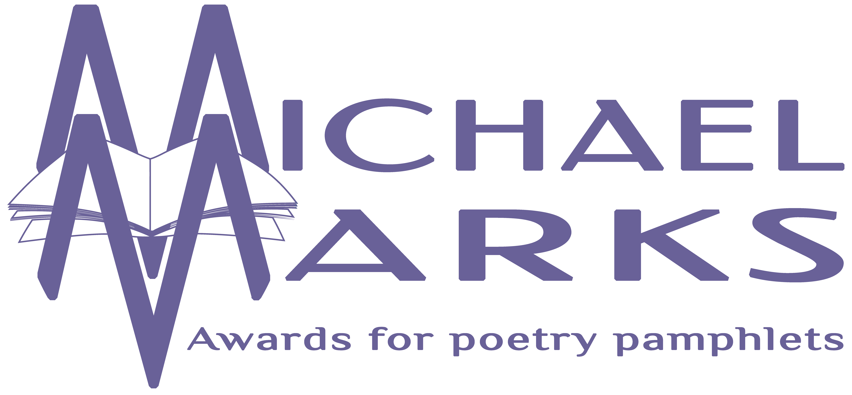

The Michael Marks Awards, 17 Orchard View, Aughton, Ormskirk, Lancashire, L39 5AD
www.michaelmarksawards.org
Email: admin@michaelmarksawards.org
Deadline for submissions: 4.00pm Wednesday 30th September 2020

Illustration Entry Form for The Michael Marks Poetry Award 2020
For pamphlets published from 1st August 2019 to the closing date of 30th September 2020.

Please see submission guidelines for rules on eligibility (available to download from www.michaelmarksawards.org/enternow). If you have any queries, please contact the Awards Administrator at the above email address for clarification. One copy of each pamphlet listed, in addition to the six copies submitted for the Poetry Award should be sent to the above address, with two copies of this form. Please provide all the details requested below. Submissions accompanied by incomplete submission forms will not be eligible. This form must be printed and signed; e-signatures will not be accepted. By signing this form you are declaring that the information thereon is correct, and agreeing to abide by the terms as described in the submission guidelines. Receipt of submissions will be acknowledged by email.

Contact Name.………………………………

Phone …......…...…….….. Email …............……………………………

Address…………………………………………………………………………………………………

…………………………………………………………………………………………………………..

Postcode……………………….

Number of Pamphlets submitted for the Illustration Award ………………….

Signature……………………………………………………………………………….

Name of Illustrator | Title of Publication

Illustrators Statement: Illustrators should make a brief statement about the medium chosen for the illustration (max. 300 words). If more than one illustrator is represented please clarify which publication the statement refers to, and add additional statements as required.

