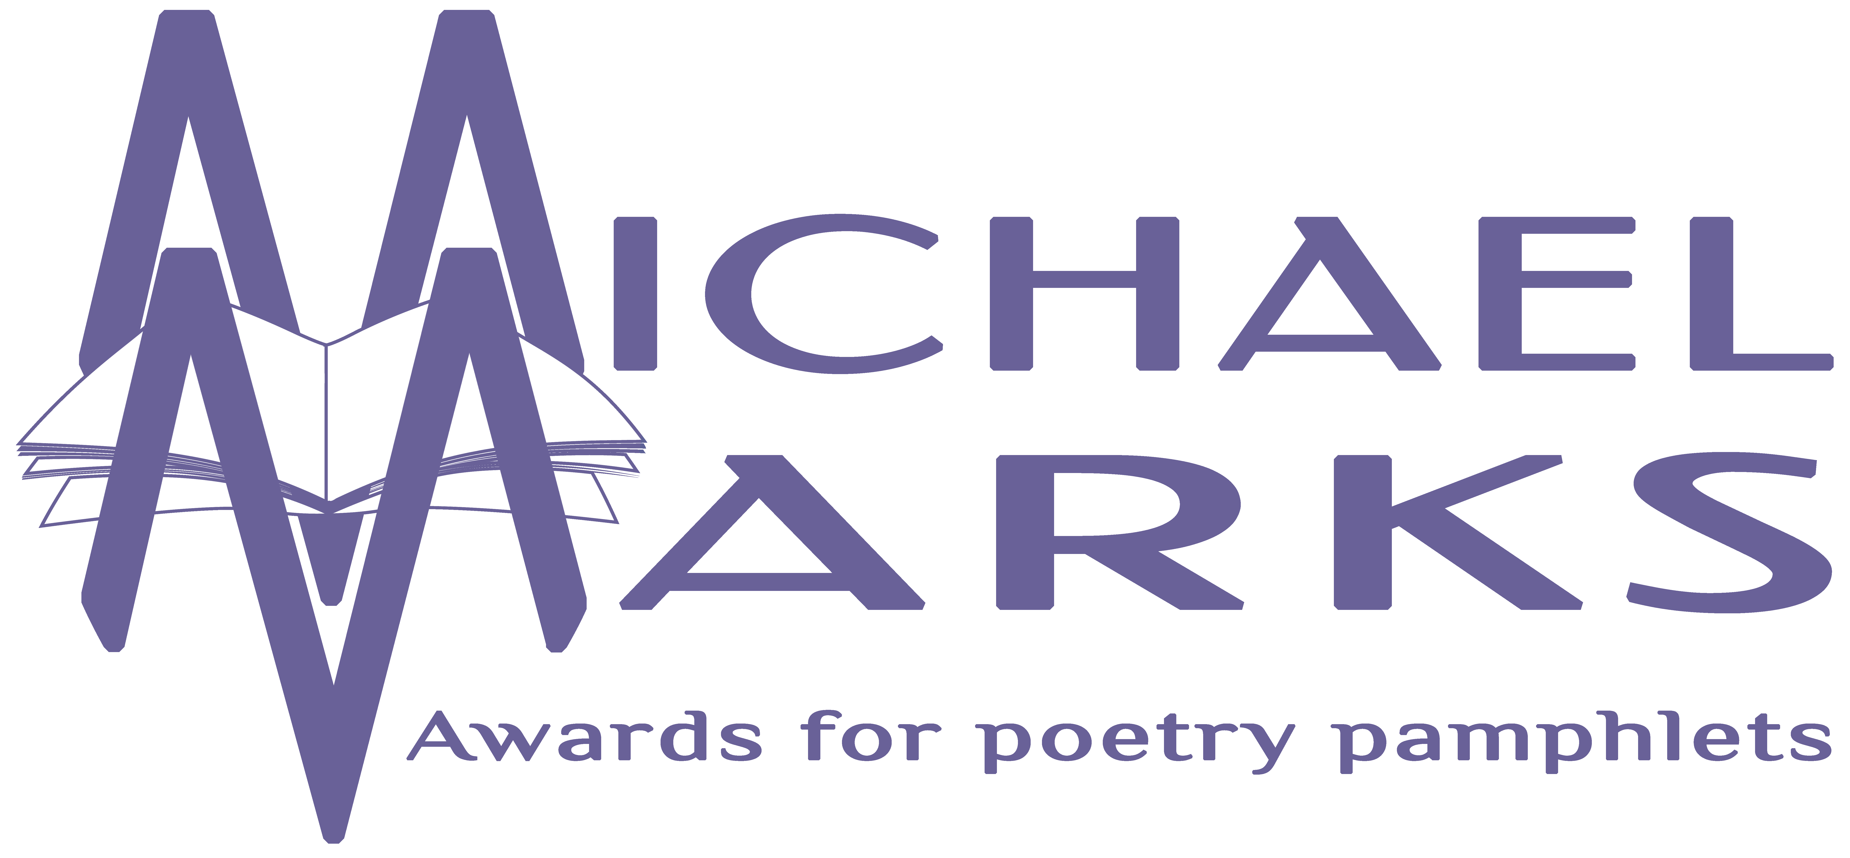

The Michael Marks Awards, 17 Orchard View, Aughton, Ormskirk, Lancashire, L39 5AD
www.michaelmarksawards.org
Email: admin@michaelmarksawards.org
Deadline for submissions: 4.00pm Wednesday 30th September 2020

Entry Form for The Michael Marks POETRY Award 2020
An Award for pamphlets published from 1st August 2019 to the closing date of 30th September 2020.

Please see submission guidelines for rules on eligibility (available to download from www.michaelmarksawards.org/enternow). If you have any queries, please contact the Awards Administrator at the above email address for clarification. Six finished copies of each pamphlet should be sent to the above address. Submissions may be made by poets or publishers. Please provide all the details requested below. Submissions accompanied by incomplete submission forms will not be eligible. This form must be printed and signed; e-signatures will not be accepted. By signing this form you are declaring that the information thereon is correct, and agreeing to abide by the terms as described in the submission guidelines. Receipt of submissions will only be acknowledged by email. Please attach a supplementary sheet if you wish to submit further titles but all titles submitted must be entered on this form or a supplementary sheet.

Name ……………………………………………………………… Phone …......…...…….…
Email …......…………………………………………………………………………………….
Address …………………………………………………………………………………………
………………………………………………………………………………………………….
Postcode ……………………
Signature ……………………………………………………………………………

Author | Title & ISBN (if applicable) | Publisher | Price

