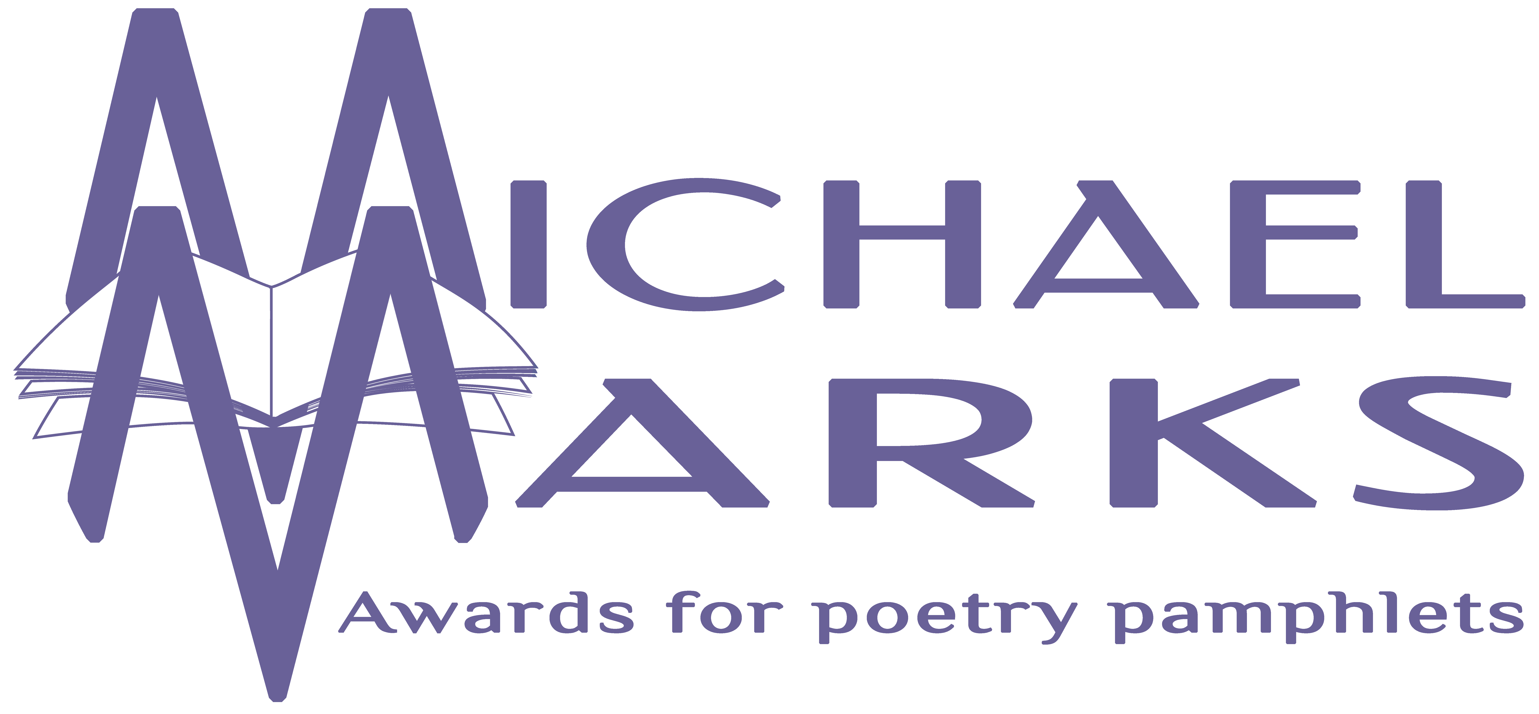
The Michael Marks Awards, 17 Orchard View, Aughton, Ormskirk, Lancashire, L39 5AD
www.michaelmarksawards.org
Email: admin@michaelmarksawards.org
Deadline for submissions: 4.00pm Wednesday 30th September 2020

Entry Form for The Michael Marks PUBLISHERS’ Award 2020
An Award for pamphlets published from 1st August 2019 to the closing date of 30th September 2020.

Please see submission guidelines for rules on eligibility (available to download from www.michaelmarksawards.org/enternow). If you have any queries, please contact the Awards Administrator at the above email address for clarification. Six finished copies of each pamphlet listed should be sent to the above address, but the copies submitted for the Poetry Award will also serve for the Publishers’ Award. In order to be considered for the Publishers’ Award, each entry must be submitted for the Poetry Award. Please provide all the details requested below and submit five copies of this form with your entry. Submissions accompanied by incomplete submission forms will not be eligible. This form must be printed and signed – e-signatures will not be accepted. By signing this form you are declaring that the information thereon is correct, and agreeing to abide by the terms as described in the submission guidelines. Receipt of submissions will be acknowledged by email.

Publisher……………………………………………Contact
Name.………………………………

Phone …......…...…….….. Email …............………………………………………

Address………………………………………………………………………………………

………………………………………………………………………………………………

Postcode……………………….

Number of Pamphlets submitted for the Publishers’ Award ………………….

Signature……………………………………………………………………………….

Author | Title

PAMPHLET PUBLISHING: Please give a brief description (max. 500 words) of your pamphlet publishing programme from September 2019 to September 2020, with a statement of your publishing philosophy, aims, strategy and future plans with regard to poetry pamphlets.

DESIGN AND PRINTING: Please provide a brief statement (max. 300 words) of the design and print criteria you employed in publishing poetry pamphlets during the period of eligibility. This will be looked at in conjunction with your submitted pamphlets.

PROMOTION: Please provide a brief statement (max. 300 words) of your sales and promotional strategy and activities for poetry pamphlets during the period of eligibility, giving examples of achievements.

